AUTO TICKET CLASSIFICATION
USING FLOW DESIGNER
ServiceNow Project Documentation

A no-code approach for automatically classifying school IT support tickets and notifying callers after ticket creation.

TEAM ID : SWTID-2026-9063
TEAM SIZE : 5
TEAM LEADER : S.SANDHIYA
TEAM MEMBER :
1.DHIVYADHARSHINI R
2.J.KANIKA
3.V.MATHUMITHA
4.M.ABINAYA

Problem Statement
A school IT helpdesk receives a steady flow of support requests from students and teachers. Typical requests include Wi-Fi connectivity problems, projector issues, forgotten passwords, and computers that are slow or unresponsive. In the existing process, IT staff review each request manually, determine the type of issue, and select the appropriate category and subcategory. As the number of tickets increases, this approach can consume considerable time and may lead to inconsistent classification.
The proposed solution uses ServiceNow Flow Designer to classify newly created tickets automatically. The flow checks keywords in the short description and assigns the relevant category and subcategory without requiring the IT agent to perform the classification manually.

Project Objectives
- Automatically classify IT support tickets when they are created.
- Reduce the amount of manual work required from IT support staff.
- Improve the routing and consistency of incoming tickets.
- Use a no-code implementation that is straightforward to maintain and extend.
- Provide an automated email acknowledgement to the caller after ticket creation.

Requirement Analysis and Planning
The helpdesk process was reviewed to identify the information that needs to be captured and the actions that should happen automatically. A ticket may relate to network connectivity, hardware, account access, or system performance.
The system is designed to support the following business requirements:
- Classify an IT ticket according to the issue described by the requester.
- Populate both Category and Subcategory automatically.
- Maintain a dependency between Category and Subcategory so that the available subcategories match the selected category.
- Send an email notification to the caller when the ticket is created.
- Store ticket information in a consistent and structured format.
- Keep the configuration simple enough for future maintenance and extension.

Update Set Configuration
A dedicated update set is used to group the configuration changes made for the project. This makes the customization easier to track and move to another environment.
- Open All and search for Update Sets.
- Under System Update Sets, open Local Update Sets.
- Select New.
- Enter Project Update Set as the Name.
- Set State to In progress.

- Set Application to Global.
- Save the record.
- From the Related Links section, select Make This My Current
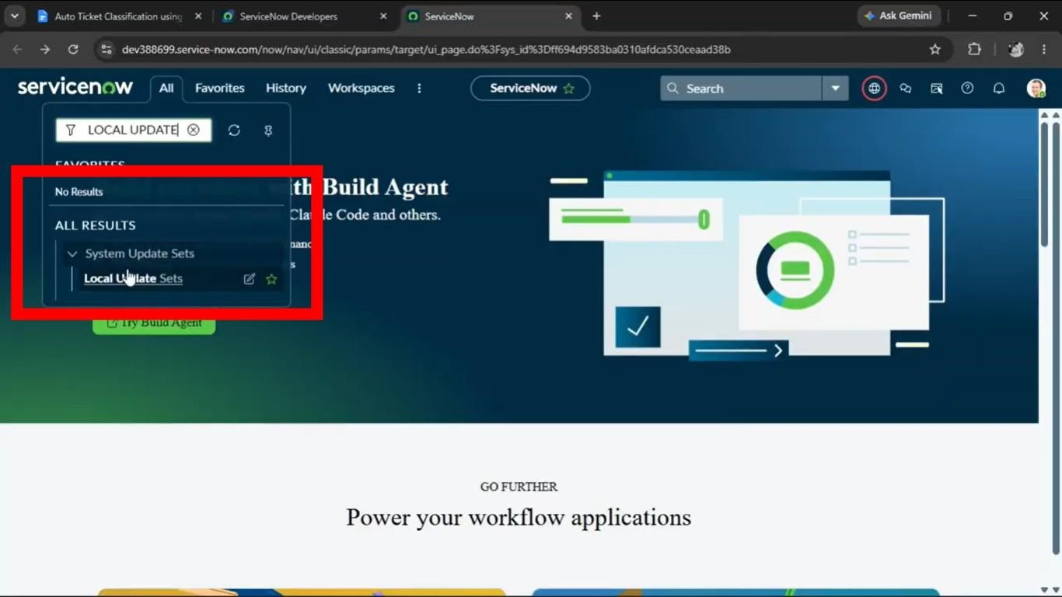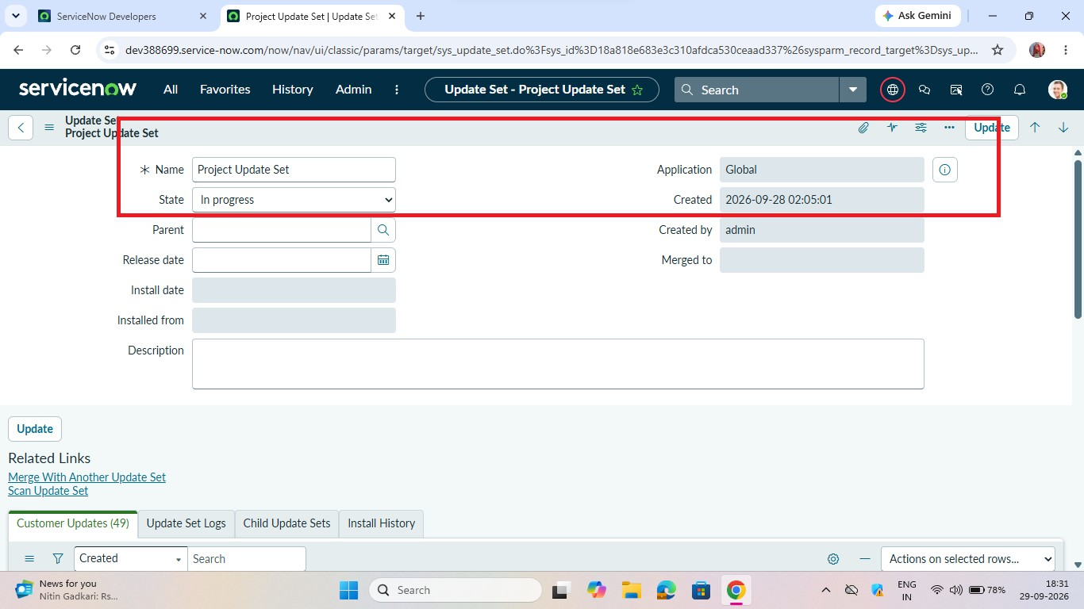
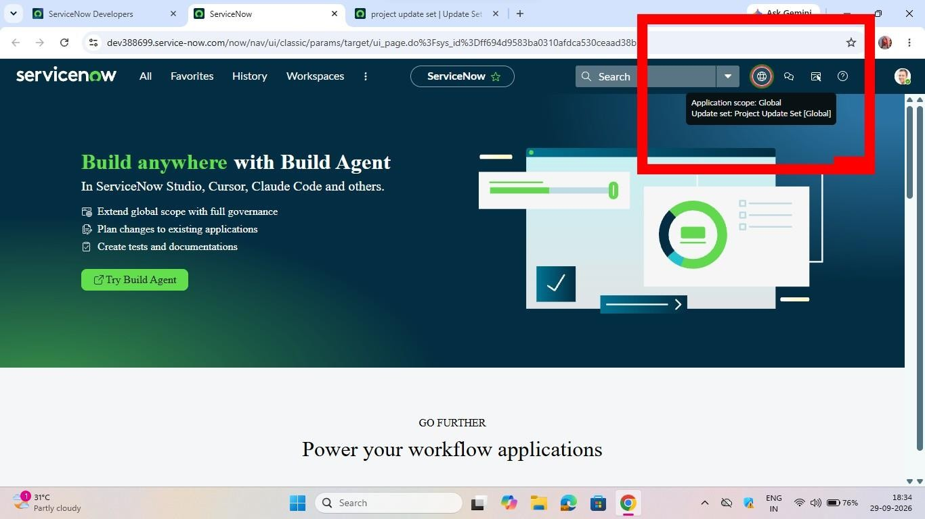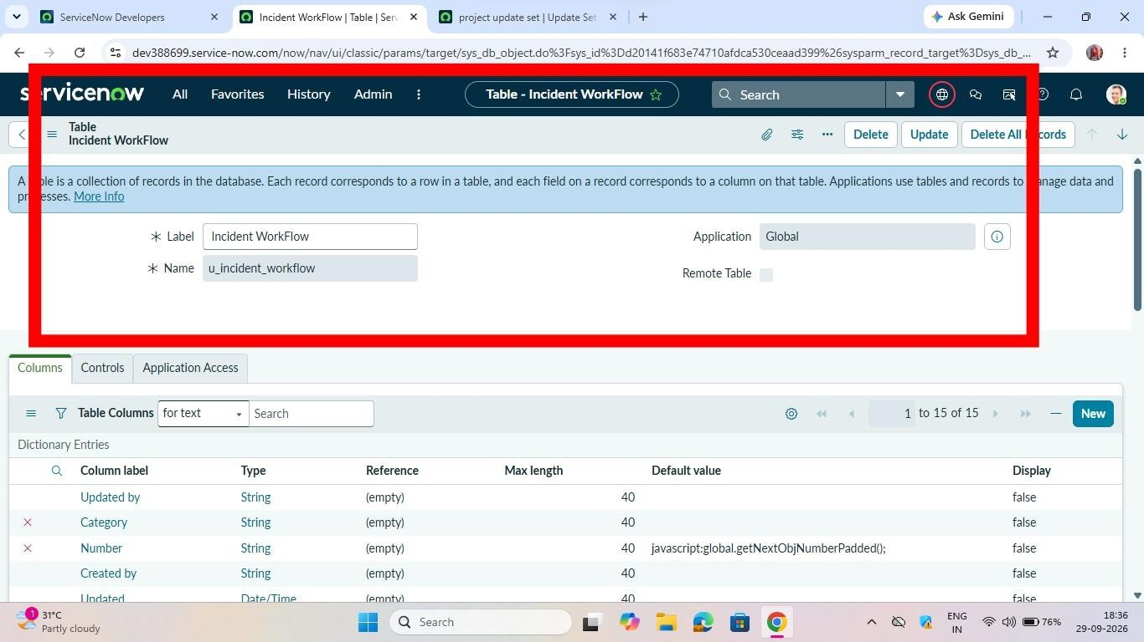
.

Backend Development and Configuration

Creating the Custom Table
A custom table is created to hold the school IT ticket records. The table is configured with an auto-number field so that each ticket receives a unique identifier.
- Open All and search for Tables.
- Under System Definition, select Tables.
- Click New.
- Set the Label to Incident WorkFlow.
- Clear the Create module option.
- Save the table.
- Open the Controls section.
- Enable the Auto Number option.
- Save the table again.
- Use the table form and Form Designer to add the fields required for the ticket record.
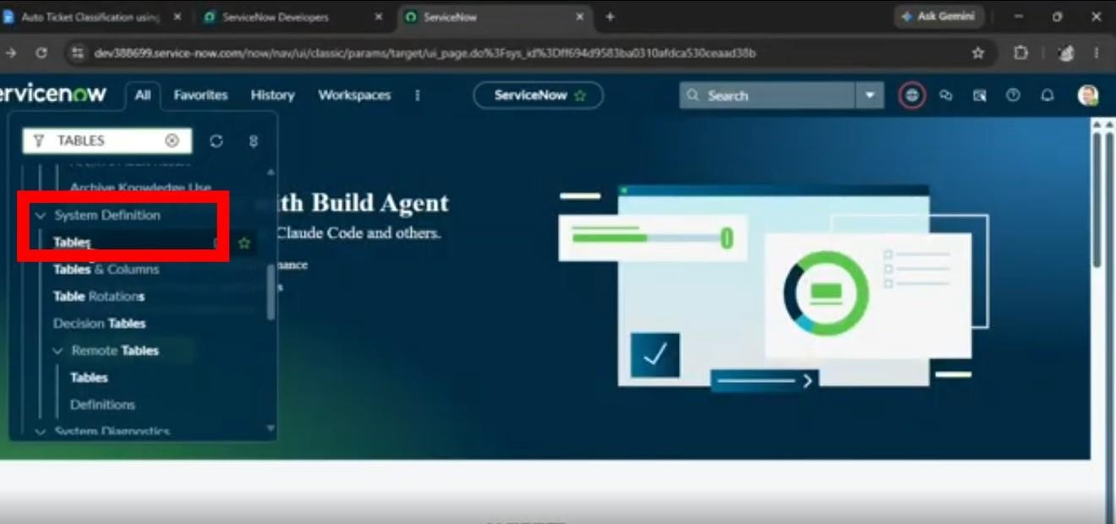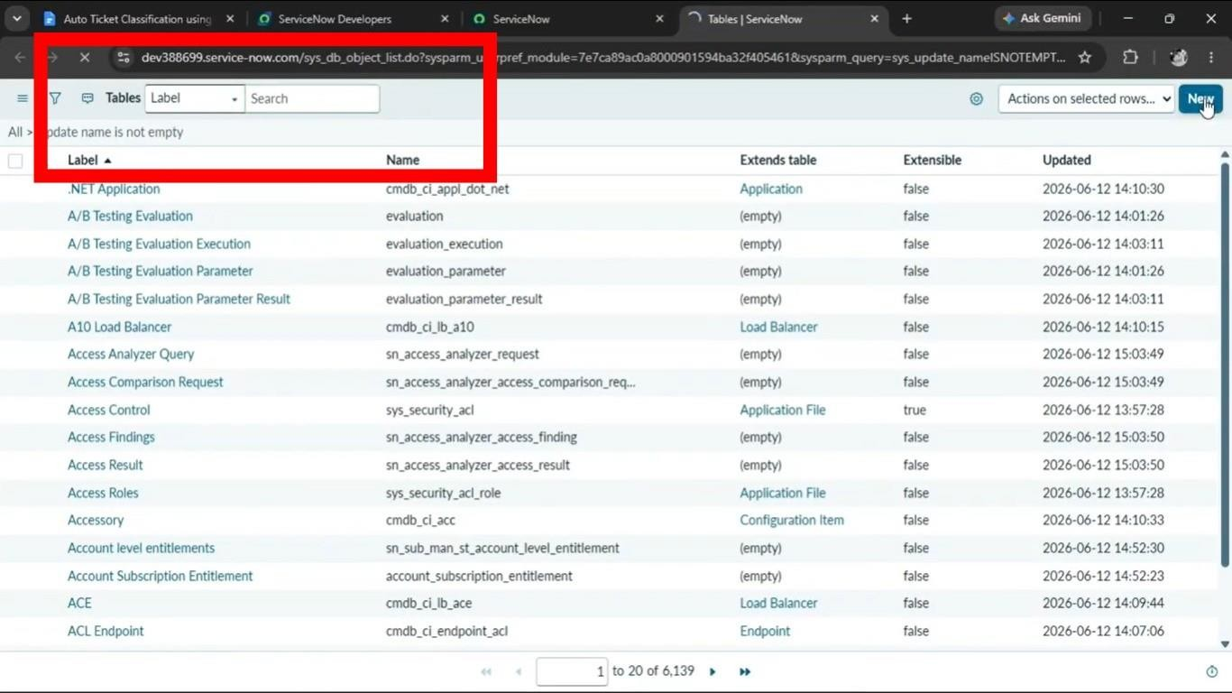
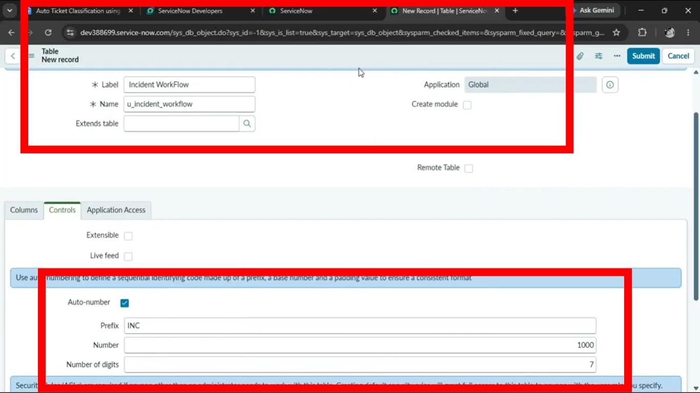

Ticket Field Configuration
The ticket table contains fields for identifying the requester, describing the issue, classifying the ticket, and tracking its assignment and state.
Field | Type | Reference / Choices
Number | Auto Number | —
Caller | Reference | sys_user
Category | Choice | Network, Hardware, Access, Performance
Subcategory | Choice | Wi-Fi, Projector, Forgot Password, Slow Computer
Short Description | String | —
Description | String | —
State | Choice | New, In progress, On hold, Resolved, Closed
Assigned Group | Reference | sys_user_group
Assigned to | Reference | sys_user
Choice values are added to Category, Subcategory, and State. After the fields and choices are configured, the form is saved and reloaded so the updated configuration is available.
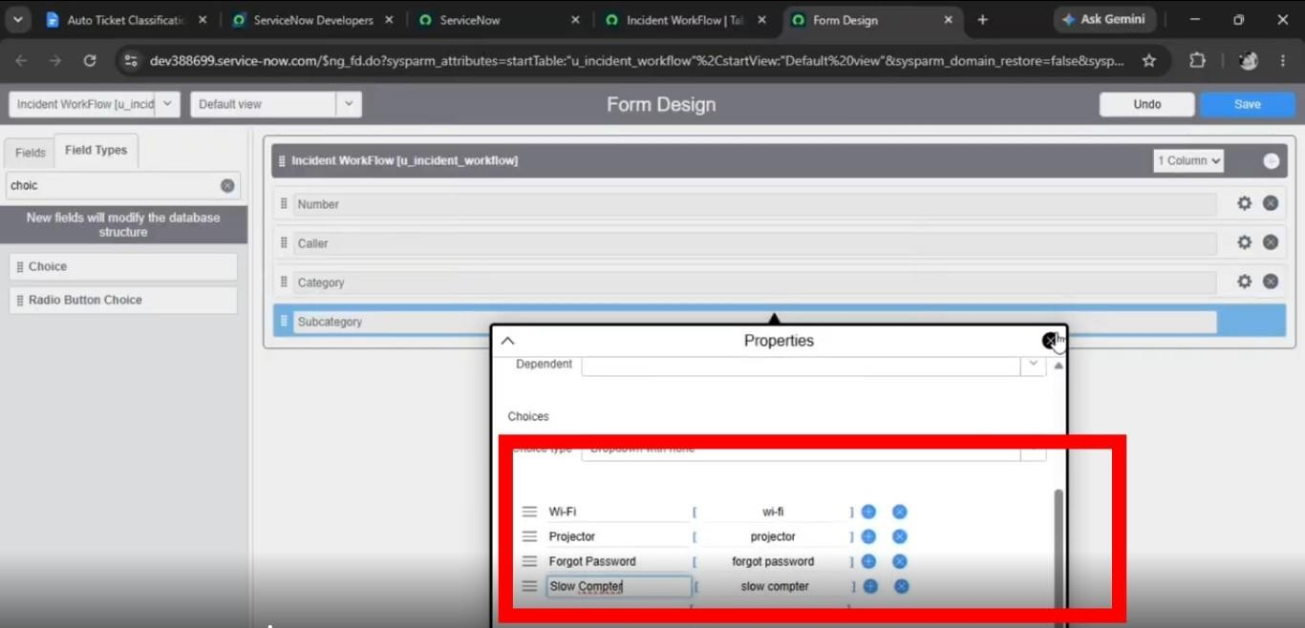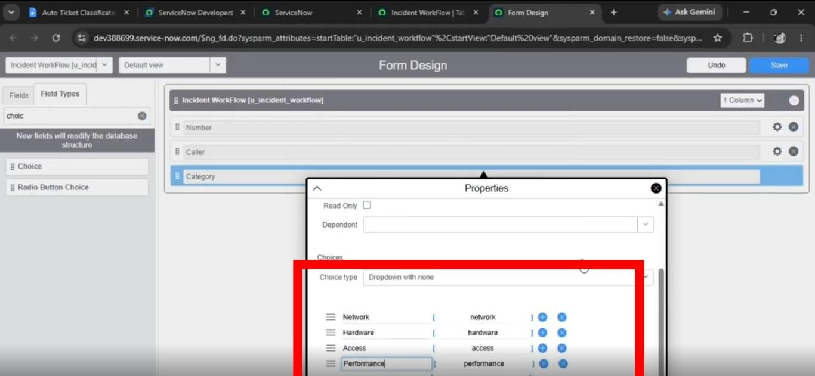

Category and Subcategory Dependency
The Subcategory field is configured as a dependent choice field. This ensures that the subcategory options are associated with the appropriate Category.
- Open the Incident WorkFlow form.
- Right-click the Subcategory field and select Configure Dictionary.
- Open the Advanced view from Related Links.
- Locate the Dependent Field section.
- Enable Use dependent field.
- Select Category in the Dependent on field.
- Save the dictionary configuration.
- In the choice section, associate each subcategory with the corresponding category backend value.
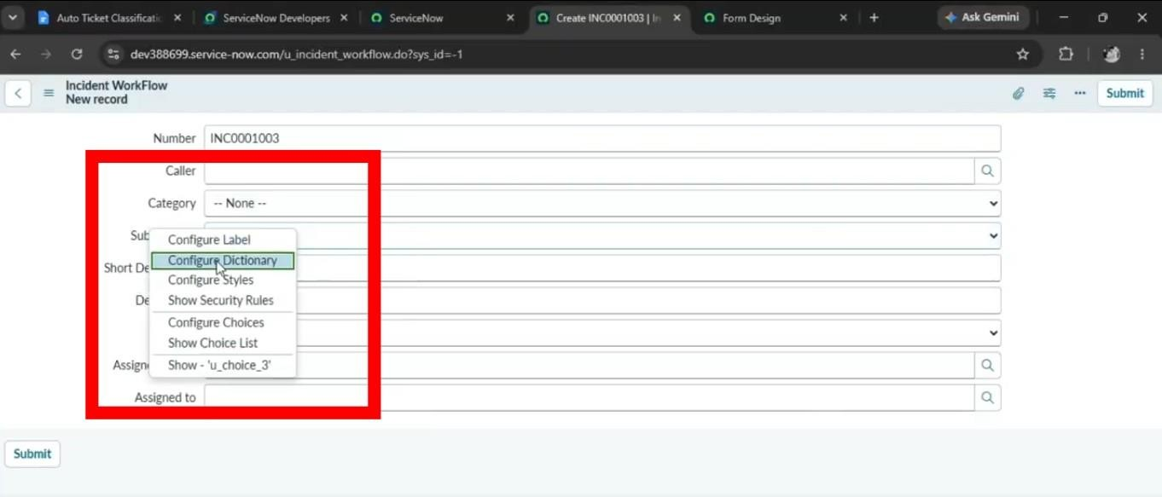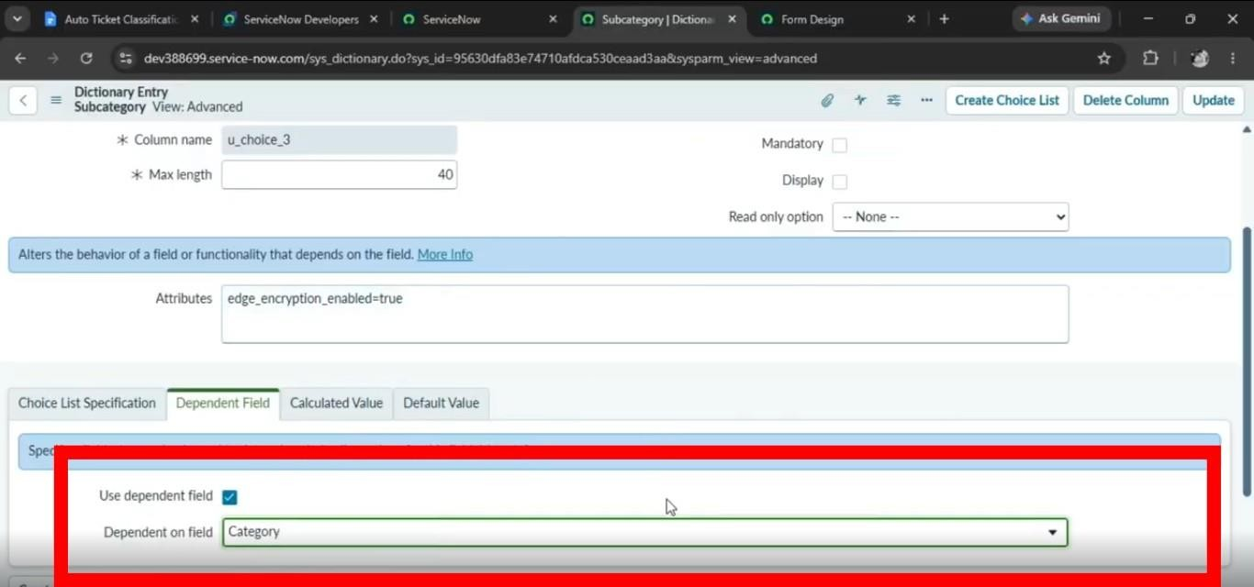
The dependency mapping used by the project is:
Subcategory | Category
Wi-Fi | Network
Projector | Hardware
Forgot Password | Access
Slow Computer | Performance

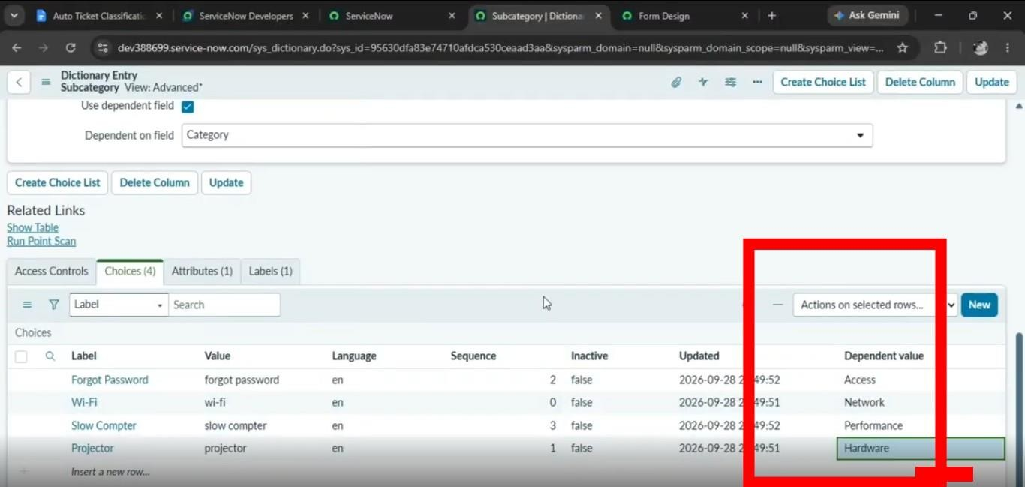
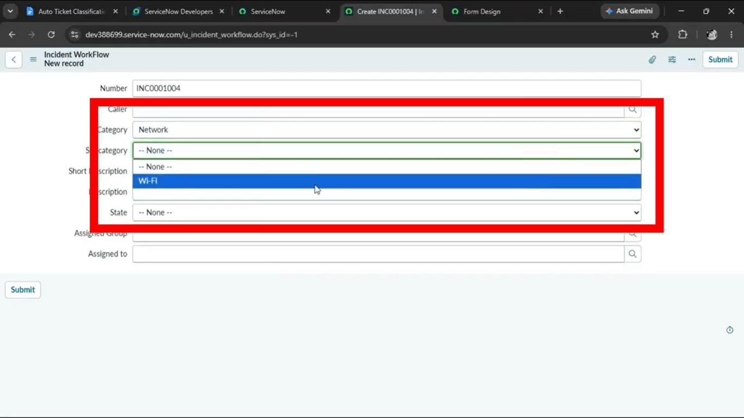
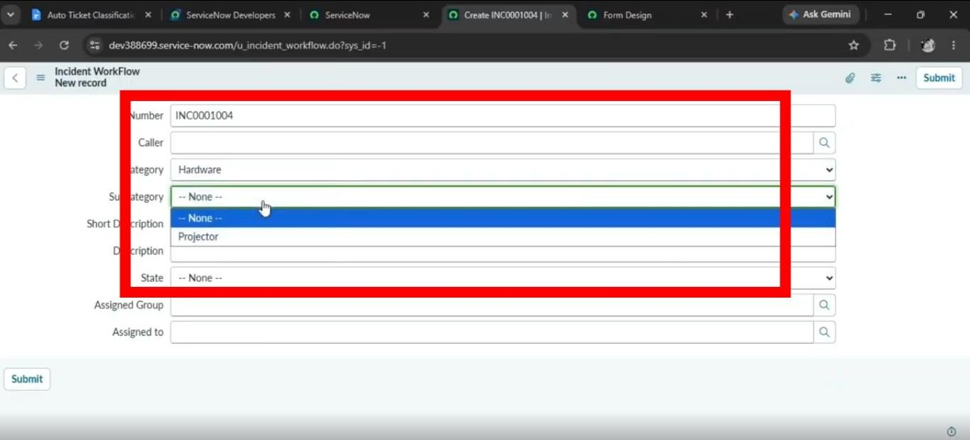

Automation with Flow Designer
The main automation is implemented in Flow Designer. When a new ticket is created, the flow checks the short description for predefined keywords. Depending on the keyword found, the flow updates the Category and Subcategory fields. After classification, an email is sent to the caller.

Create the Flow
- Open All and search for Flow Designer.
- Under Process Automation, open Flow Designer.
- Select New and choose Flow.
- Set the flow name to Auto Classify School IT Tickets.
- Set Application to Global.
- Select Build Flow.

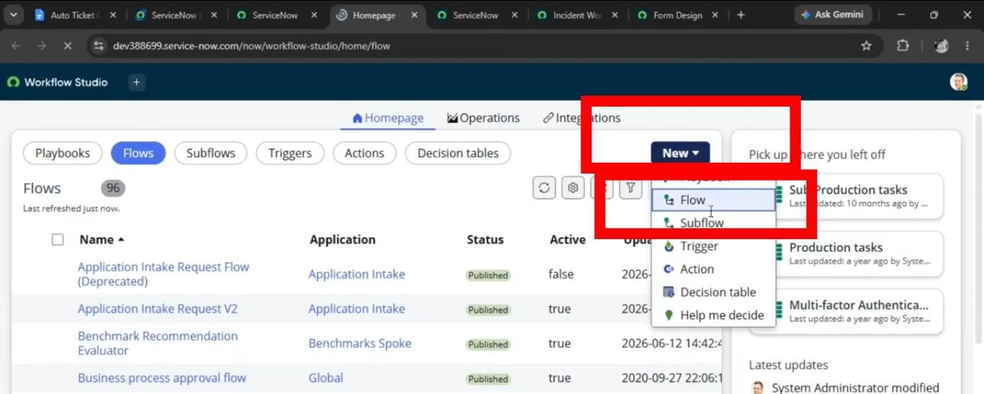

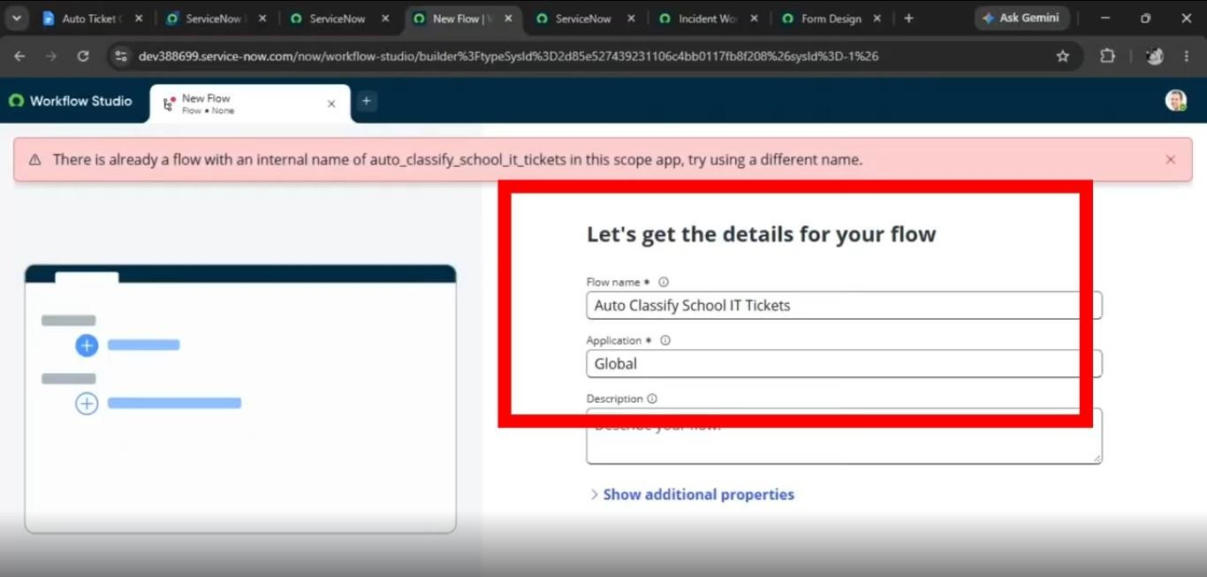

Configure the Trigger
Use the following trigger configuration:
- Trigger: Record Created
- Table: Incident Workflow
- Condition: Category is empty
Select Done after configuring the trigger.
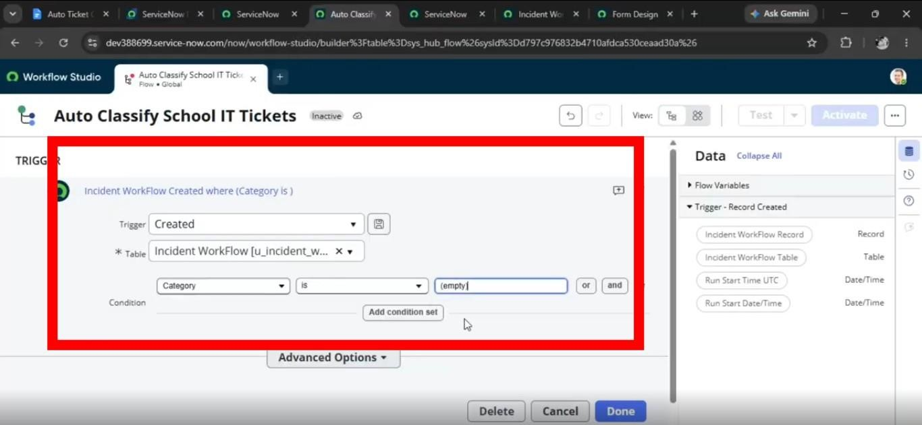

Wi-Fi / Network Classification
The first condition checks whether the Short Description contains either Wi-Fi or Network.
- Condition type: If
Condition label: SD is WiFi or Network
- Short Description contains: Wi-Fi
- Short Description contains: Network
- Action: Update Record
- Category: Network
- Subcategory: Wi-Fi
- 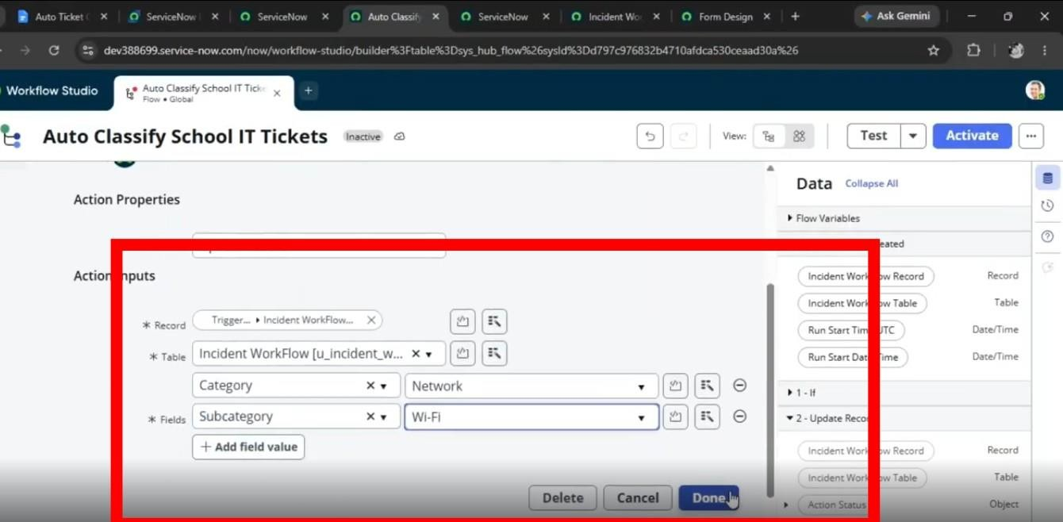

Projector Classification
- Condition type: Else If
- Condition label: SD is Projector or Hardware
- Short Description contains: Projector
- Action: Update Record
- Category: Hardware
- Subcategory: Projector
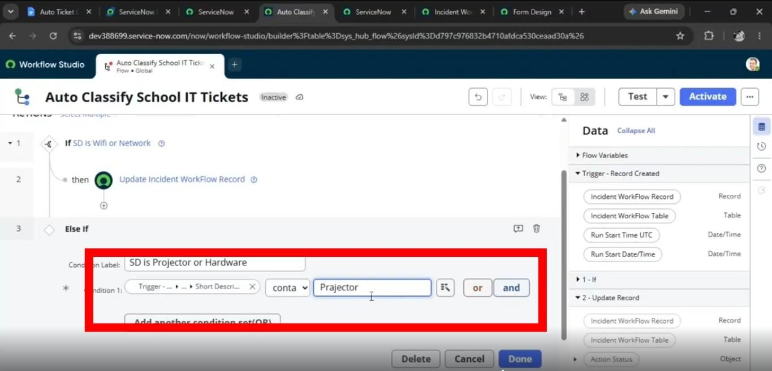
- 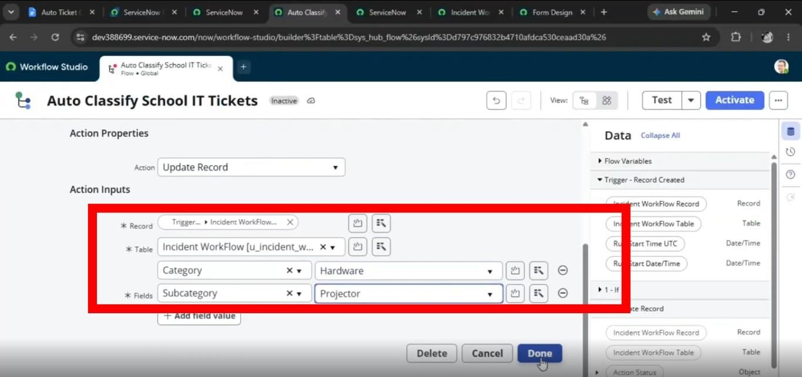

Password / Access Classification
- Condition type: Else If
- Condition label: SD is Forgot Password
- Short Description contains: Forgot password
- Action: Update Record
- Category: Access
- 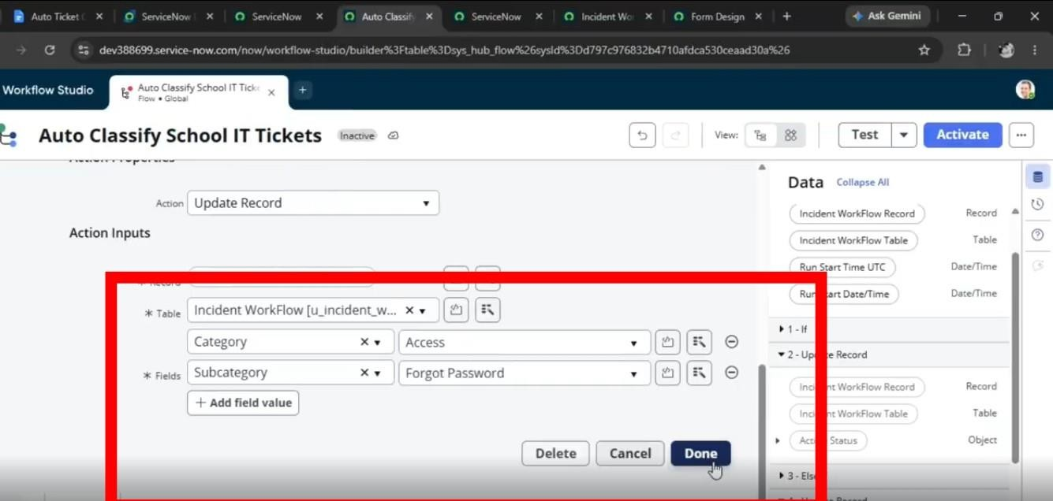

Slow Computer Classification
- Condition type: Else If
- Condition label: SD is Performance
- Short Description contains: Slow Computer
- Action: Update Record
Category: Performance

- Subcategory: Slow Computer

- 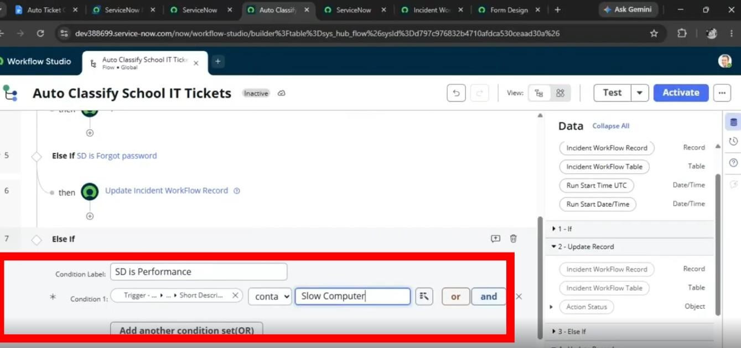

- 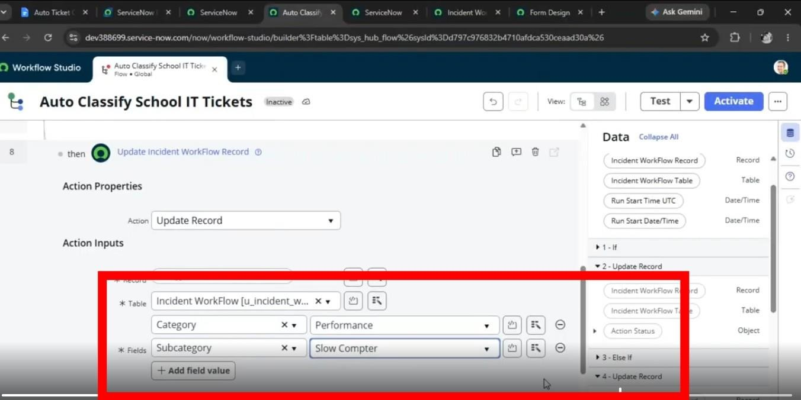

Email Notification
After the ticket is classified, the flow sends an email confirmation to the caller.
- Action: Send Email
- To: Caller → Email
- Subject: Your Request for the issue has been submitted.
- Body: Ticket confirmation message
•
Once all conditions and actions are configured, save the flow and select Activate.
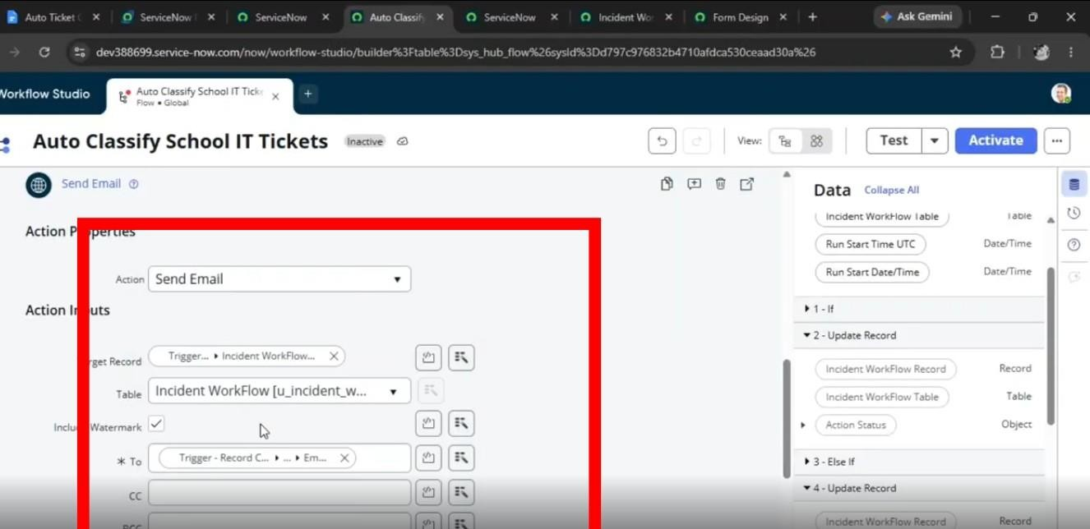

Testing, Validation and Security
The solution is tested end-to-end to confirm that ticket data is stored correctly, classification occurs as expected, and the caller receives the notification.

Validation Checks
- Required ticket information is captured correctly.
- The ticket number is generated without duplication.
- Category and Subcategory values are populated correctly
• 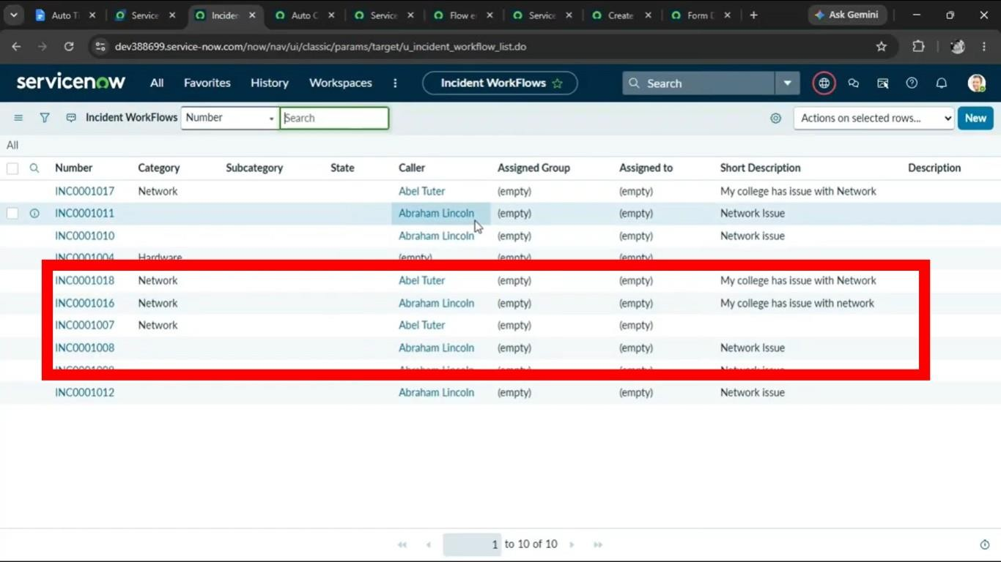
.
- Reference fields resolve to the appropriate user and group records.
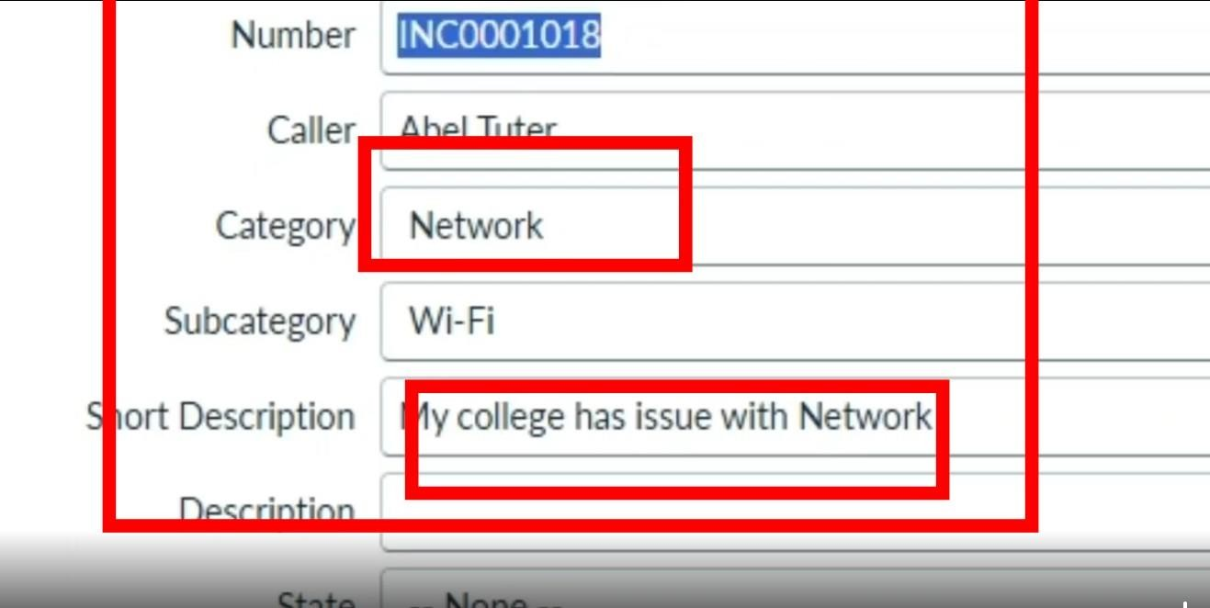

Test Scenario 1 – Wi-Fi Issue
- Enter a Caller.
- Set Short Description to: WiFi not working in library.
- Save the form.
- Reload the form.
- Verify Category is set to Network.
- Verify Subcategory is set to WiFi.
- Verify that an email is sent to the caller's email address.

Verify the Email
- Open All and search for Emails.
- Under System Logs, select Emails.
- Search using the configured subject.
- Open the corresponding email record.
- From Related Links, select Preview mail to review the generated message.

Test Scenario 2 – Projector Issue
- Enter a Caller.
- Set Short Description to: Projector not turning on.
- Save the form.
- Reload the form.
- Verify Category is set to Hardware.
- Verify Subcategory is set to Projector.
- Verify that an email is sent to the caller's email address.

Deployment and Final Documentation
After testing is complete, the project update set is moved to the Complete state and exported so the configuration can be transferred to another ServiceNow environment.
- Open All and search for Local Update Sets.
- Under System Update Sets, select Local Update Sets.
- Open Project Update Set.
- Change State from In progress to Complete.
- Save the record.
- From Related Links, select Export to XML.
- Save the exported XML file for transfer or sharing.
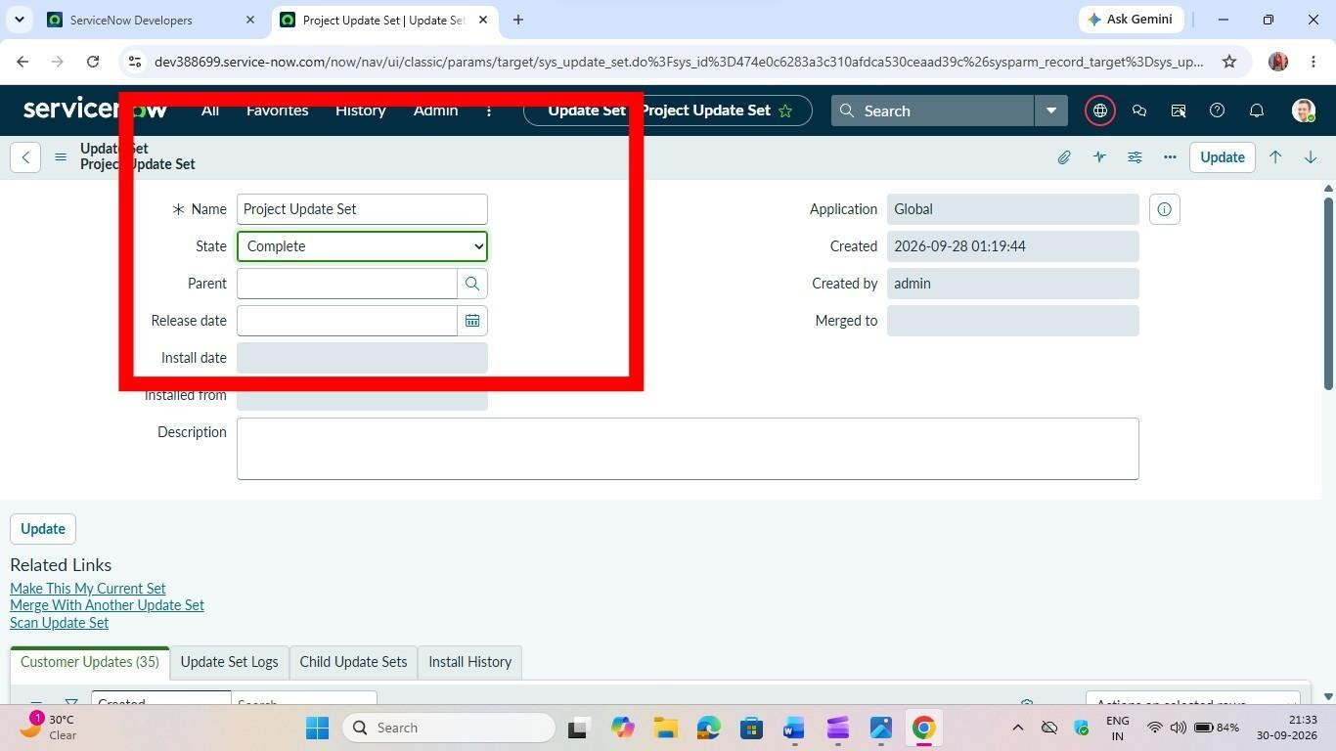

Conclusion
The Auto Ticket Classification using Flow Designer project provides an end-to-end approach for handling common school IT support requests. Instead of requiring support staff to classify every new ticket manually, the configured flow identifies predefined keywords in the ticket description and assigns the corresponding Category and Subcategory.
The dependent choice configuration helps keep ticket data consistent, while the automated email action provides immediate confirmation to the caller. The use of Flow Designer keeps the solution within a no-code configuration model and makes the workflow easier to maintain.
The project also includes validation scenarios for Wi-Fi and projector issues, along with email verification and update-set deployment steps. The same design can be extended later with additional classification conditions, assignment automation, SLA tracking, or other ServiceNow capabilities.

DEMO LINK: https://drive.google.com/file/d/1Os3sGGsKMznoOV38jNjz1LbgOf1S4IRK/view?usp=drivesdk

